Assignment – 3

Hypothesis testing

Question 1: A F&B manager wants to determine whether there is any significant difference in the diameter of the cutlet between two units. A randomly selected sample of cutlets was collected from both units and measured? Analyze the data and draw inferences at 5% significance level. Please state the assumptions and tests that you carried out to check validity of the assumptions.

Minitab File : Cutlets.mtw

Solution: file attached in the name **“a_3 Hypothesis testing sol vin”**

Let us assume Null hypothesis (ho) = µ1=µ2, there is no difference in diameters of cutlets between two units.

Alternative hypothesis (h₁) = µ1≠µ2, there is difference in diameters of cutlets between two units)

Two tail test is applied.

Ttest_indResult(statistic=0.7228688704678063, pvalue=0.4722394724599501)

As P value is greater than 0.05 accepting the null hypothesis that there is no difference in diameters of cutlets between two units.

Question 2 : A hospital wants to determine whether there is any difference in the average Turn Around Time (TAT) of reports of the laboratories on their preferred list. They collected a random sample and recorded TAT for reports of 4 laboratories. TAT is defined as sample collected to report dispatch.

Analyze the data and determine whether there is any difference in average TAT among the different laboratories at 5% significance level.

  Minitab File: LabTAT.mtw

Solution : file attached in the name **“a_3 Hypothesis testing sol vin”**

Let us assume, Null hypothesis (ho) = all samples TAT population means are same that is no variance.

Alternative hypothesis (h₁) = all samples TAT population means are not same, at least one sample TAT population has different mean that is it has variance.

Anova test is applied**.**

F_oneway Result(statistic=118.70421654401437, pvalue=2.1156708949992414e-57)

As P value is less than 0.05 accepting the alternative hypothesis that at least one sample TAT population mean is different, it has variance.

Question 3 : Sales of products in four different regions is tabulated for males and females. Find if male-female buyer ratios are similar across regions.

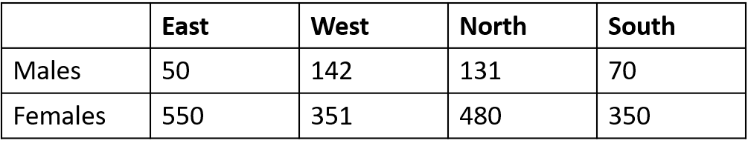

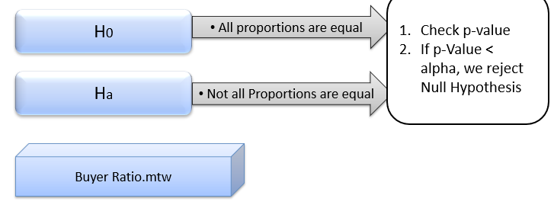

Solotion : file attached in the name **“a_3 Hypothesis testing sol vin”**

Let us assume, Null hypothesis (ho) = male-female buyer ratios are similar across all the regions. they do not vary and independent.

Alternative hypothesis (h₁) = male-female buyer ratios are not similar across all the regions. they vary and may be significantly related.

Chi square test is applied.

P value is = 0.660

As P value is greater than 0.05,accepting the null hypothesis that male-female buyer ratios are similar across all the regions.they do not vary and independent.

Question 4 : TeleCall uses 4 centers around the globe to process customer order forms. They audit a certain % of the customer order forms. Any error in order form renders it defective and has to be reworked before processing. The manager wants to check whether the defective % varies by centre. Please analyze the data at *5%* significance level and help the manager draw appropriate inferences

Minitab File: CustomerOrderForm.mtw

 Solution : file attached in the name **“a_3 Hypothesis testing sol vin”**

Let us assume, Null hypothesis (ho) = customer order forms defective percentage does not vary by centre. It doesn’t vary and independent.

Alternative hypothesis (h₁) = customer order forms defective percentage varies by centre.

P value = 0.277

As P value is greater than 0.05 Accepting the null hypothesis that customer order forms defective percentage does not vary by centre.